Viral Attack is a fun way to learn how the immune system works. The comic book format allows you explore the basics of this very important defense system and provides a way to move on to more advanced topics when you are ready.
Story Behind the Scenes by Kelly Dolezal
Illustrated by Sabine Deviche and Dr. Biology

Prologue
Prologue: a section before a story or movie that introduces characters and important information.
There are battles that are fought each day around the planet. The invading forces are those of viruses and bacteria. Left alone they would take over and destroy every cell!
It is up to some key defense systems to battle and destroy these forces. Our immune system is one such defense system. A collection of special cells in our body are ready to attack any unwanted bacteria and virus. Together these cells are able to seek out and destroy unwanted viruses and return our bodies to their normal working order.
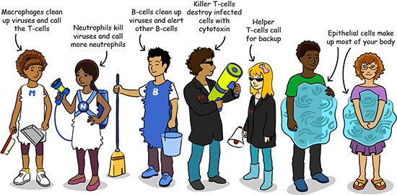
Macrophages clean up viruses and call the T-cells.
Neutrophils kill viruses and call more neutrophils.
B-cells clean up viruses and alert other B-cells
Killer T-cells destroy infected cells with cytotoxin
Helper T-cells call for backup
Epithelial cells make up most of your body
Cast
This story has young actors playing the role of the cells that fight infections in our body. Each cell has a special job that they do that helps our body do work and fight off infections like viruses. As you will see there are many different cells that work together to fight off infections like viruses.
Our story begins with a sore throat, the kind that is red and hurts when you swallow.
Ughhh [sounds of not feeling well coming from a young boy who is sick, in bed]
The attack started as a single virus that multiplied in the body to become an invading army. Left alone, they would take over and destroy every cell.
It is up to some key defense systems to battle and defeat these forces.
Let’s see how these specialized cells that are part of the immune system work together to return our bodies to working order.
Our bodies have many types of cells. One type is called the epithelial cell.
This epithelial cell is nice and happy, but not for long…
Hehehe [sounds of laughter coming from a virus that is sneaking up on an epithelial cell character]
Ahhh! [the epithelial cell character yells as…]
Whoosh [the virus slams into the epithelial cell]

At first, the virus is inside just a few cells in the throat, not causing too much harm. The body doesn’t even notice.
Hey, you’re just one itsy bitsy virus. [the epithelial character looks down at the large cell making up her body] This isn’t so bad.
But the problem with viruses is… they multiply! Two days later:
Ughh, I don’t feel too good. [the epithelial character now has many viruses in her cell body]
I’m going to need some help!
[she moves toward the alarm button, which says “Help!”]
Click [sound as she pushes the button, causing an alarm to go off]
Uh-oh, too late!
Rumble [sound of thunder, as this character’s body cell seems more upset]

Ka-pow! [sound of explosion, as the cell bursts, releasing many viruses]
What a mess! Look at all these loose viruses.
We need to get these cleaned up quickly or the other epithelial cells will be in terrible danger!
Hello! [two new characters show up]
You’re just in time!
We heard your alarm. I’m Neutrophil.
I’m Macrophage. We’re members of the body’s immune system clean-up crew.
Let’s get this mess cleaned up! [macrophage starts sweeping up viruses into a dust pan]

Take that, viruses! [neutrophil shoots the viruses with a web gun]
They’re multiplying too fast!
It’s more than we can clean up alone.
We need to do something quickly or these leftover viruses will attack other epithelial cells. [a new epithelial cell is already infected and filled with viruses]
Time to call for backup.
[Macrophage calls out] T-cells, we need your help!
[Killer T-cell and Helper T-cell fly in and land]
Where are the infected cells?
Hey Killer and Helper T-cell. I don’t feel too good.
Thunk [sound of something heavy landing]

Looks like we’re too late for this one. He has too many viruses inside already.
Killer T, you’ll have to destroy the cell. It’s the only way to stop more viruses from being released.
Ok!
Viruses, meet my cytotoxin gun!
Whirl [sound of spinning as the gun gets ready]
Click [sound of a trigger]
[Killer T shoots the infected cell with neon yellow cytotoxin]

Blam! [sound of an explosion]
Pop! [sound of viruses popping off of the epithelial cell character’s body]
It’s working! [the infected cell with viruses inside starts to fall off of the epithelial cell character]
Good job, Killer T!
Thanks, Helper T. But there are still some viruses around.
Yuck! [the epithelial character is grossed out as he steps in dead infected cell and viruses]
Sizzle [sound of something frying, coming from the dying infected cell]
No problem, I’ll just call for back up. [Helper T-cell pulls out her megaphone to yell into it]
B-cell, we need your help!

[B cell shows up on the scene, holding a broom and a bucket]
Hi, B-cell.
Hey, Helper T!
What a mess! Let’s get these viruses all cleaned up.
Swish [sound of sweeping, as B cell cleans up]
Grrrr [sound of growling coming from the viruses being removed]
I don’t see any left… looks like that’s the last of them.
The body should be feeling much better now!
And now to alert the other B-cells to this virus. [B-cell is posting a “wanted” poster with the virus pictured on it]
All the B-cells that see this will become memory B-cells. They’ll be able to quickly recognize this virus if it ever comes back.

I’m feeling much better today. My immune system really came to the rescue! [Boy from the beginning of the story is sitting up in bed, and the sun is shining outside]
The End
Credits
Original script by Sholly Fisch
Revised Script by Laura Martin & Charles Kazilek
The Story Behind the Scenes by Kelly Dolezal
Illustration by Sabine Deviche
Coloring by James Baxter & Sabine Deviche

Viruses
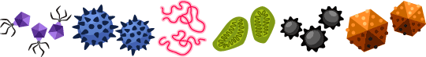
Cartoon image of various small, virus-like cells
Camouflage: use of colors and patterns to blend into the surrounding area in order to hide.
Capsid: a protective shell around the genome of a virus.
Cell membrane: the outside layer of a cell that separates it from its environment.
Envelope: part of a cell membrane that is stolen to become the outer layer of some viruses.
Genome: all of the genetic information of an organism (living thing).
Homeostasis: the ability to keep a system at a constant condition.
Immune system: all the cells, tissues, and organs involved in fighting infection or disease in the body.
Metabolism: what living things do to stay alive. This includes eating, drinking, breathing, and getting rid of wastes.
Mutualist: a virus or living thing that grows inside or alongside a living host, helping both of them grow better than if they were alone.
Pathogen: a virus, bacterium, fungus or parasite that infects and harms a living host.
Remember the last time you had a sore throat, fever or cough? There is a good chance that you felt sick because your body was fighting a virus, a tiny invader that uses your cells to copy itself. Viruses can infect every known living thing. Animals, plants, and even bacteria catch viruses. Bacteria or viruses that make other living things sick are called pathogens.
Even though we try to stay away from pathogens, many other bacteria and viruses are helpful. Bacteria that live in the oceans and soil are important to cycle nutrients in the environment. Other bacteria turn milk into yogurt or cheese for us to eat.
There are even some helpful viruses and bacteria that live inside you, called mutualists. Some viruses and bacteria inside you actually help guard your body against more dangerous infections, and other viruses can help plants survive cold or droughts better. Bacteria in your guts help you digest your food and make vitamins you can’t make yourself.
If we were able to see viruses with our eyes, we would see that they are all around us. Luckily, your immune system can remove most viruses that make you sick. In some cases, doctors give us medicines that can slow down difficult viruses to help your immune system fight them.
Catching viruses
There are many ways viruses can get into the body. Insects, like mosquitoes, can spread some viruses between people they bite. More often, the viruses that cause colds come from infected people through a sneeze or cough. Once out, they can get in your body when you inhale them from the air or touch a surface they are stuck to.
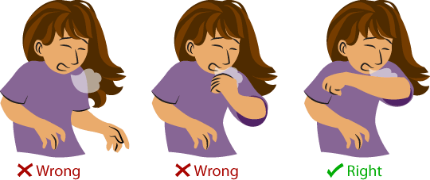
Image of girl coughing without covering her face at all (labeled as “wrong”), coughing into her hand (labeled as “wrong”), and coughing into her elbow (labeled as “right).
There are ways to stay healthy and to keep others from getting sick from viruses. The best way is to wash your hands. The soap won’t kill viruses, but it does help remove the oils and dirt they stick to so you can rinse them off your skin. When you are sick, you can protect others by covering your mouth and nose when you cough. Don’t use your hands, because you can end up touching something and spreading the virus. Instead, use your upper arm and shoulder to cover your mouth and nose.
What does a virus look like?
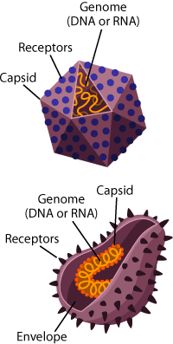
An image of a virus, showing the outer shell (capsid) covered in receptors, with the virus’ genome (DNA or RNA) inside.
How Big?
Think about this – even if we could magnify a cell until it was the size of a basketball, a virus would still only be about the size of a single period on this page.
Virus parts
The simplest viruses have only two parts: 1) a genome (DNA or RNA) that is a blueprint with instructions for making more viruses and 2) a capsid protein shell that protects the genome. Viruses also often have proteins called receptors that stick out of the shell, and help the virus sneak inside cells.
Many viruses that infect humans and animals also have an envelope, something like a cell membrane, around the capsid and genome.
These are just the basics, though. Below are images taken with an electron microscope showing you just a few of the many different shapes of viruses.
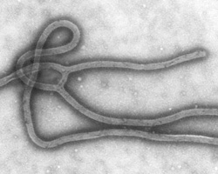
A microscope image of the Ebola virus. Image from CDC Public Health Image Library
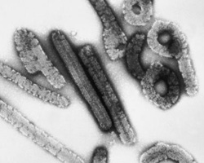
A microscope image of Marburg virions. Image from CDC Public Health Image Library.
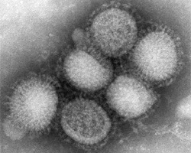
A microscope image of swine flu virus. Image from C. S. Goldsmith and A. Balish, CDC
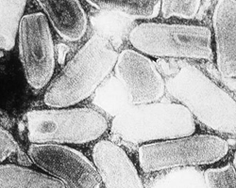
A microscope image of vesicular stomatitis virus. Image from CDC Public Health Image Library.
How does a virus work?
You might not think that simple viruses could take over your complex cells, but they do all the time. This is very important to viruses because they don’t have the machinery to make copies of themselves. Instead, they trick your cells into becoming virus-making machines for them.
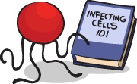
A cartoon virus reading a cartoon book called “Infecting cells 101”
A virus guide to infecting cells
Step one is to get inside a cell. Viruses enter the cell by tricking it into thinking it is something else that the cell needs. On the cell surface, there are sensors called receptors with shapes that fit with the shape of nutrients. When a matching receptor and nutrient lock together, the cell pulls them both inside.
A virus uses camouflage to trick the cell. Its capsid or receptor proteins look like nutrients the cell needs. When the virus receptor binds to the cell receptor, the cell thinks the virus is a nutrient, and pulls it in. Now the cell is infected!
Making more viruses
Step two is to make more viruses. Once inside, the virus adds its genome blueprint to the cell. The cell doesn't know that the new blueprint is from the virus, so it follows the instructions to make virus parts. Now the cell has unknowingly become a virus factory. The virus parts come together to make full viruses that escape from the cell. Each new virus can infect another cell, repeating the infection cycle.
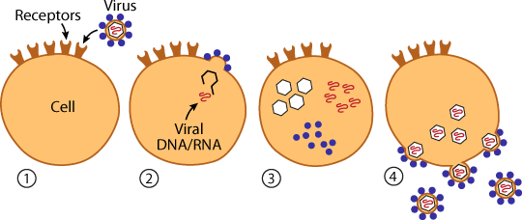
A cartoon image showing how proteins on the virus bind to receptors on the outside of a cell. Once inside, the virus releases its DNA or RNA into the cell, which instructs the cells to build more copies of the virus. These new viruses are released, either through budding (shown here) or through destruction of the cells.
Are viruses alive?
Viruses seem very smart to trick your cells during infections, but are they actually alive? It’s difficult to come up with one definition for life, but scientists agree on several characteristics that all living things share. Let’s see how viruses stack up.
First, living things must reproduce. Although viruses have a genome, they need to take over the machinery of other living cells to follow the virus genome instructions. So, viruses cannot reproduce by themselves.
Next, all living things have metabolism. Metabolism means the ability to collect and use energy. Chemical reactions in your cells constantly change molecules into forms of energy we can use. The energy you use to run and jump came from breaking big food molecules into smaller pieces that can be used or stored in the cell. Viruses are too small and simple to collect or use their own energy– they just steal it from the cells they infect. Viruses only need energy when they make copies of themselves, and they don't need any energy at all when they are outside of a cell.
Finally, living things maintain homeostasis, meaning keeping conditions inside the body stable. Your body sweats to cool you down and shivers to warm you up if its temperature changes from 98.6 ° F. Millions of adjustments throughout the day keep your temperature and the chemicals in your body balanced. Viruses have no way to control their internal environment and they do not maintain their own homeostasis.
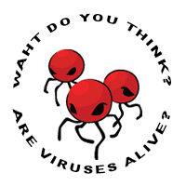
A cartoon image of viruses surrounded by the text “What do you think? Are viruses alive?”
So, since viruses cannot reproduce on their own and have no metabolism or homeostasis, they are usually not thought of as truly alive. They do have a huge effect on living things during infections, though!
What do you think? Should viruses be included with other living things? After you decide why you think they should or should not be considered alive, listen to biochemist Nick Lane and Dr. Biology discuss if they think viruses are alive (only in English).

Epithelial Cells
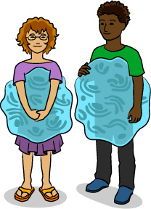
An image of our two epithelial cell characters.
Where are epithelial cells?
Take a quick look at the skin on your hands. Even if you think your skin is one smooth surface, it is actually made of millions of epithelial cells that are tightly packed next to each other.
That’s not the only place you find these cells. Epithelial cells also line the inside of your throat, intestines, blood vessels, and all your organs. They are a barrier between the inside and outside of your body and are often the first place that is attacked by viruses as they begin their invasion deeper into the body.
What do epithelial cells do?
Epithelial cells are the safety shields of the body. Take another look at your hand. It is covered with epithelial cells that protect your body by being a barrier between your internal cells and the dirt and microbes in the environment. They also are able to stretch so you can move your fingers and arms into many positions. You can also thank your epithelial cells for making the sweat that cools you down when you're exercising or when it's hot outside. To learn more about your skin and the important ways it works for you every day, listen to this podcast (in English only).
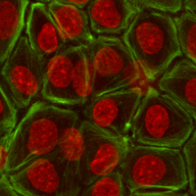
A microscope image of stained epithelial cells by Page Baluch
Other epithelial cells help you experience your environment by having special sensors, called receptors, that collect signals. When you taste a favorite food or smell a flower, the receptors in these cells send the signal to your brain so you can enjoy every bite and sweet smell.
Once you swallow that bite of food, it travels down a path lined with epithelial cells. When it gets to your intestines, another set of epithelial cells absorbs and transports nutrients from the foods you eat and helps process it for energy your body can use. Converting food energy to energy your body can use is the work of molecules called enzymes. Once again, it is epithelial cells that make and secrete the enzymes in your stomach. Epithelial cells also secrete hormones into your blood vessels, mucus in your nose and the breast milk which mothers feed their young.
What do epithelial cells look like?
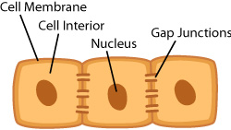
An illustration of epithelial cells, showing the outer layer of the cells (the cell membrane), the cell interior, the nucleus, and connections between the cell, called gap junctions.
If you take a close look at epithelial cells using a microscope, you will see them tightly packed together. This helps make a protective barrier for our bodies. There are also some special door-like connections between each epithelial cell called gap junctions. The gap junctions are where the cells exchange nutrients. Unfortunately, sometimes viruses can use these doors to spread between cells, too!
Epithelial cells come in different shapes depending on where in the body they're found. These shapes are called squamous, cuboidal, columnar, and ciliated columnar.
Squamous epithelial cells are flat and are usually found lining surfaces that require a smooth flow of fluid such as your blood vessels. They also line areas that require a very thin surface for molecules to pass through, such as the air sacs in your lungs.
Cuboidal epithelial cells, as their name suggests, are shaped like cubes. These are typically found in tissues that secrete or absorb substances, such as in the kidneys and glands.
Columnar epithelial cells are long and thin, like columns. These are usually found in places that secrete mucus such as the stomach. They can also specialize to receive sensory information in places like taste buds on your tongue and inside of your nose.
Ciliated columnar cells have their apical (or outside facing) surface covered with many tiny little hairs called cilia. These are used to push mucus and other particles along, making it flow in a specific direction.
In addition to these shapes, epithelial cells can be described as being either simple or stratified. These terms refer to how many layers are present. Simple tissue has only one layer of epithelial cells, while stratified tissue has many layers stacked on top of each other. Stratified cells are found in places that need to withstand a lot of wear and tear from their environment.
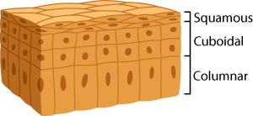
An illustration of stratified cells. The upper layer of flattened cells are labeled “squamous.” The middle layer of square cells are labeled “cuboidal.” The lower layer are tall and rectangular and are labeled “columnar,” and look like long columns.
An example of this would be your skin, which is made up of many stratified layers of epithelial cells. As the top layer wears down, cells from the bottom layers constantly grow up to replace them.

Macrophages
An illustration of the character “Macrophage”
Early to the scene
Macrophages, a kind of white blood cell, are one of the first types of cells at the infection (along with neutrophils). They get to the infection from your blood. Your blood looks like it is just a red fluid but it has lots of other kinds of cells, too. There are red blood cells that bring oxygen to every part of your body and white blood cells that fight infections.
Getting to the scene
Infected or damaged cells, like the epithelial cells in our story, call for help by releasing chemicals to attract macrophages. These chemicals also open spaces between blood vessel cells. Macrophages can squeeze between the spaces to get to the action!
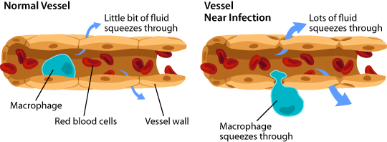
An illustration that shows how a blood vessel can change to let helpful cells into the tissues when there is an infection. The spaces between the cells open.
When cells call for help
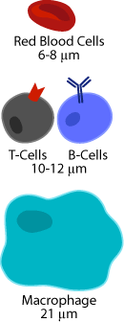
An illustration comparing the sizes of red blood cells (the smallest, 6 to 8 micrometers) to T-cells and B-cells (10 to 12 micrometers), to macrophages (21 micrometers).
Have you ever had a splinter that after a day or two felt painful, hot, and swollen? Your cells around the splinter were calling for help, and when the blood vessels let macrophages in the infected tissue, they also let some blood fluid seep into the area. This extra fluid and the chemicals released by infected cells can cause inflammation. This hurts, but actually helps your body fight infections better!
Bringing in more help
Macrophages and neutrophils work to keep the body clean of debris and invaders, but they also call for backup when an infection is too big for the two of them to handle alone. Other immune system cells, like the T-Cells and B-Cells in our story, are alerted that their help is needed by chemicals the macrophages release. Macrophages are also linked to the presence of other types of cells like basophils and eosinophils, which are most often involved in allergic reactions. These cells also help control the inflammation of tissues.
Big Eaters
Think of macrophages as cell-eating machines. Their name actually means “big eater” in Greek. Macrophages are the biggest type of white blood cells - about 21 micrometers - or 0.00083 inches. Still too small to see with your eyes, but big enough to do the important job of cleaning up unwanted viruses, bacteria, and parts of dead cells.
Macrophages don’t eat cells the same way you might eat your food. Instead, the eating machines engulf viruses and bacteria. This is called phagocytosis. First, the macrophage surrounds the unwanted particle and sucks it in. Then, the macrophage breaks it down by mixing it with enzymes stored in special sacs called lysosomes. The leftover material is then pushed out of the cell as waste.
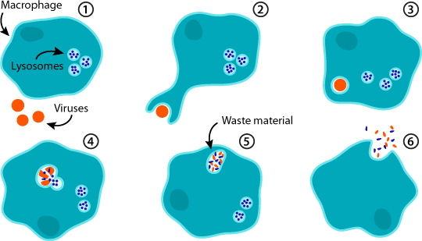
An image showing the steps of phagocytosis: Once a macrophage engulfs a virus, it’s broken down with enzymes from the lysosomes. It is then released from the cell as harmless waste material.
Macrophages in action
References:
Video from Judith Behnsen on Wikimedia Commons.

Neutrophils
Macrophage: an immune cell that engulfs foreign material and dead cells... more
Neutrophil: an immune cell that is one of the first responders to an infection or injury; they fight by eating invaders, shooting chemicals at them, or setting web-like traps for them. Neutrophils are the most common type of white blood cell in humans…
Early to the scene
Neutrophils are the most common type of white blood cell. They are also usually the first cells at the scene of infection. They are made in the bone marrow, and like other white blood cells, they travel through the bloodstream to the infection. Scientists are still trying to learn all the ways they are involved in fighting viruses. But one of the most important ways they help fight is by releasing chemicals.
Helping and hurting
Neutrophils fight off invaders in a number of ways. They can eat them, fire anti-microbial proteins at them, or set web traps outside of cells, to catch and kill them. But some of these weapons can also do damage to the cells that make up body tissues. A situation like this is called a trade-off. The help neutrophils offer is important to win the fight, but they also hurt at the same time that they help.
Bringing cells to the fight
Neutrophils also release chemicals that call more cells to the fight. This can happen throughout the body, or in a specific body tissue. It all depends on where the virus or microbe is attacking. When a fight happens in one area, tissue can get swollen and hot. This "inflammation" happens because cells and fluids are moving to the area and can cause tissue damage.
Keep it short
Because neutrophils both help and hurt during a fight against microbes, using them in battle is a bit of a balancing act. But their short lives help keep things under control. As long as the fight against invaders continues, neutrophils are called to replace cells that die. But after the infection is under control, no more cells should be called. The remaining neutrophils will start to die soon. In most cases, they will be swallowed up by macrophages, so the area of infection will be clean.

T-Cells
T-cells are a type of white blood cell that works with macrophages. Unlike macrophages that can attack any invading cell or virus, each T-cell can fight only one type of virus. You might think this means macrophages are stronger than T-cells, but they aren’t. Instead, T-cells are like a special forces unit that fights only one kind of virus that might be attacking your body.
More than one kind of T-cell
There are two types of T-cells in your body: Helper T-cells and Killer T-cells. Killer T-cells do the work of destroying the infected cells. The Helper T-cells coordinate the attack.
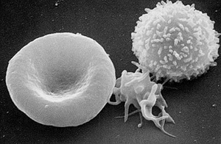
Picture taken with a scanning electron microscope of a T cell (right), platelet that helps blood to clot (center) and a red blood cell (left). The bumps on the T cell are T-Cell receptors used to fight infections (CDC – Wikimedia)
Killer T-Cells and Antigens
Killer T-cells find and destroy infected cells that have been turned into virus-making factories. To do this they need to tell the difference between the infected cells and healthy cells with the help of special molecules called antigens. Killer T-cells are able to find the cells with viruses and destroy them.
Antigens work like identification tags that give your immune system information about your cells and any intruders. Healthy cells have 'self-antigens' on the surface of their membranes. They let T-cells know that they are not intruders. If a cell is infected with a virus, it has pieces of virus antigens on its surface. This is a signal for the Killer T-cell that lets it know this is a cell that must be destroyed.
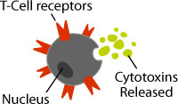
An illustration of a T-cell releasing cytotoxins.
Anatomy of a T-cell
T-cells have many identical T-cell receptors that cover their surface and can only bind to one shape of antigen. When a T-cell receptor fits with its viral antigen on an infected cell, the Killer T-cell releases cytotoxins to kill that cell.
The key to finding infected cells
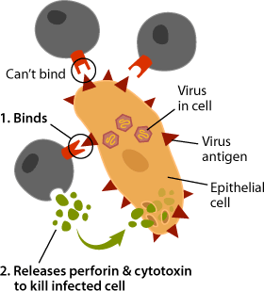
An illustration of an infected cell that only one out of three T-cells can bind to in order to identify it. The T-cell then releases cytotoxin to kill the infected cell.
There are 25 million to a billion different T-cells in your body. Each cell has a unique T-cell receptor that can fit with only one kind of antigen, like a lock that can fit with only one shape of key. Antigens and receptors work a lot like a lock and key. Most of these antigens will never get in your body, but the T-cells that patrol your body will recognize them if they do.
The T-cell receptor fits with its antigen like a complex key. When the perfectly shaped virus antigen on an infected cell fits into the Killer T-cell receptor, the T-cell releases perforin and cytotoxins. Perforin first makes a pore, or hole, in membrane of the infected cell. Cytotoxins go directly inside the cell through this pore, destroying it and any viruses inside. This is why Killer T-cells are also called Cytotoxic T-cells. The pieces of destroyed cells and viruses are then cleaned up by macrophages.
Helper T-cells
The other type of T-cell is the Helper T-cell. These cells don’t make toxins or fight invaders themselves. Instead, they are like team coordinators. They use chemical messages to give instructions to the other immune system cells. These instructions help Killer T-cells and B-cells make a lot more of themselves so they can fight the infection and make sure the fight stays under control.
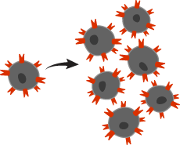
An illustration of a T-cell making copies of itself. When a T-cell finds its virus match in your body, it makes many copies of itself to attack that virus.
Building a bigger army for a particular invader
When a Helper T-cell sends out a chemical message, its matched Killer T-cell is alerted that there is a virus present. After a Killer T-cell finds and destroys an infected cell, this Helper T-cell message tells it to copy itself, making an army of Killer T-cells. Because only T-cells that can fight the invading virus are copied, your body saves energy and is still very good at killing the virus.
T-cell screening
T-cells are made in the bone marrow, like all red and white blood cells. The name T-cell comes from the organ where they mature, the thymus. The thymus is just above your heart, and is about the size of a deck of playing cards. Most T-cells are made when you’re young, so kids have a bigger thymus than adults. It is also where T-cells are screened to get rid of any that would attack the healthy cells in your body.
Getting around the body
All white blood cells have two ways to get around the body. One way is through your blood vessels. The other way is through the lymph system.
The lymph system has vessels that move milky fluid and white blood cells around the body. Unlike your heart, which pumps your blood, the lymph system uses the movements of your body to push the lymph fluid around. This is one reason why it is good to be active and exercise.
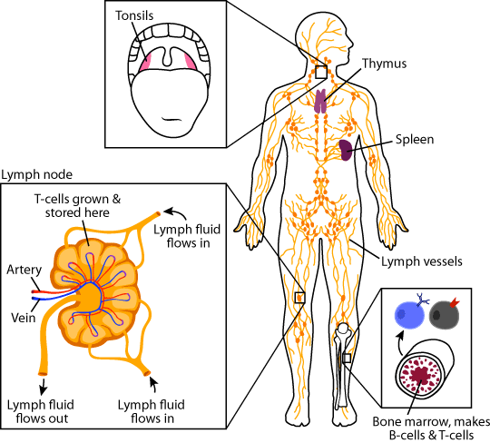
An illustration of the anatomy of the lymph system. The lymph system moves white blood cells around the body. It includes the lymph nodes, the thymus, spleen, tonsils, and bone marrow, where immune cells grow and multiply.
Switching transportation systems
Most white blood cells are stored in the lymph system until they are needed to fight an infection. When a virus attacks, they can transfer into the blood vessels so they can quickly attack the viruses. This transfer happens in the lymph nodes, which are located throughout your body.
Lots of lymph nodes are in your legs, armpits, and neck. The last time you had a sore throat you probably felt enlarged places on one or both sides of your neck. This is where the T-cells and B-cells multiply and get ready to attack the virus.
Other important parts of the lymph system where immune cells grow, multiply, and trap invaders are your bone marrow, thymus, spleen, and tonsils.
Apoptosis: self-destruction of a cell.
Cytotoxins: chemicals that kill cells.
Lysis: cell death because of damaged membranes.
Cytotoxins
Cytotoxins are the chemical weapons that Killer T-cells use to destroy infected cells. Viruses take over healthy cells and trick them into making many more viruses. When those viruses get out, they can infect even more healthy cells. By killing infected cells before these viruses get out, cytotoxins protect your healthy cells.
Different kinds of cytotoxins work in different ways. Some cytotoxins make holes in the cell membrane, so the inside of the cell is not protected from the outside. Without a full membrane, the cell dies. Cell death because of this kind of break in the cell membrane is called lysis.
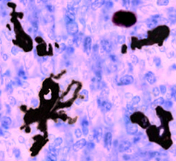
Other cytotoxins turn on a program in the cell that causes it to self-destruct. This is called apoptosis. This image shows purple stained cells, with dark spots throughout the image. The dark spots in the picture are cells that have been destroyed by apoptosis. Macrophages, the first member of the body's clean up crew, remove these dead cells.

B-Cells
An image of a duck with the thymus (in the neck) and the Bursa of Fabricius (in the digestive system) both labeled.
You might think B-cells got their name because they are made inside your bones. It is true that most blood cells are made inside the bone marrow, but that is not where the “B” in B-cells came from. Their name comes from the name of the place they were discovered, the Bursa of Fabricius. The Bursa is an organ only found in birds.
An illustration of our B-cell character.
Unlike T-cells and macrophage cells, B-cells don’t kill viruses themselves. In the Viral Attack story, the B-cell sweeps up the leftover viruses after the T-cell attack. Actually, B-cells are as important as T-cells and are much more than just a final clean-up crew. They make important molecules called antibodies. These molecules trap specific invading viruses and bacteria. Without this line of defense, your body would not be able to finish fighting most infections.
B-cell, T-cell, what’s the difference?
Just like T-cells, each B-cell has a receptor that will connect to only one antigen shape. And, like T-cells, B-cells that recognize self-antigens are destroyed, so they don’t harm your body’s healthy cells.
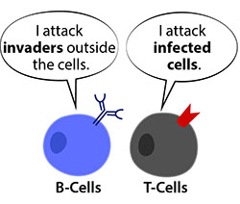
An illustration of a B-cell and a T-cell. The B-cell is saying “I attack invaders outside the cells,” and the T-cell is saying “I attack infected cells.”
An important difference between T-cells and B-cells is that B-cells can connect to intact antigens right on the surface of the invading virus or bacteria. This is different from T-cells, which can only connect to parts of virus antigens on the outside of infected cells.
Your body has up to 10 billion different B-cells. They’re too small to see with your eyes, but if you lined them all up, they’d be longer than 100 soccer fields. With so many different B-cells patrolling your body, you are ready to fight almost any invader.
B-cells become plasma cells
When a B-cell receptor connects to its specific antigen, a Helper T-cell releases chemicals that tell that B-cell to divide many times. This makes an army of B-cells with the perfectly shaped B-cell receptor to connect to the invader in your body.
Many of these B-cells quickly turn into Plasma cells. Plasma cells make and release antibodies that connect to the same antigen as the original B-cell receptor. Plasma cells make thousands of antibodies per second, which spread throughout your body, trapping any viruses they see along the way.
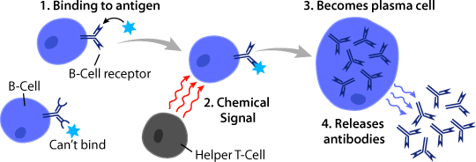
An illustration showing B-cells releasing antibodies. First, the B-cell with a matching receptor binds to an antigen. Then, the helper T-cell sends the B-cell a message that antibodies are needed. The B-cell transforms into a plasma cell and releases antibodies to fight the virus.
What do antibodies do?
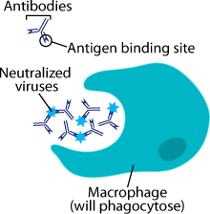
An illustration showing antibodies attaching to viruses with their antigen binding sites. The antibodies make the virus unable to infect cells, and gather them in large clumps. A macrophage will then come along and phagocytose the clumped viruses.
Antibodies trap invading viruses or bacteria in large clumps. This makes it easy for macrophages to eat them. Antibody-coated viruses are called “neutralized” because they can’t infect your cells.
Even after you have fought off your infection, some antibodies stay in your blood. If that virus tries to infect you again, your immune system has a head start trapping it.

Memory Cells
If your body fights a virus once, the same virus will probably try to attack again. After all the work it took to get rid of that first infection, it would be a shame to have to do it all over again. An amazing feature of your immune system is that it remembers the infections it has fought. This makes it much easier to fight the same virus or bacteria a second, or third, or fourth time.
A Memory Cell never forgets
Towards the end of each battle to stop an infection, some T-cells and B-cells turn into Memory T-cells and Memory B-cells. As you would expect from their name, these cells remember the virus or bacteria they just fought. These cells live in the body for a long time, even after all the viruses from the first infection have been destroyed. They stay in the ready-mode to quickly recognize and attack any returning virus or bacteria.
Quickly making lots of antibodies can stop an infection in its tracks. The first time your body fights a virus, it can take up to 15 days to make enough antibodies to get rid of it. With the help of Memory B-cells, the second time your body sees that virus, it can do the same in thing 5 days. It also makes 100 times more antibodies than it did the first time. The faster your body makes antibodies, the quicker the virus can be destroyed. With the help of Memory B-cells, you might get rid of it before you even feel sick. This is called gaining immunity.
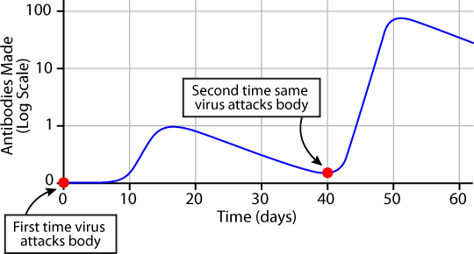
This graph shows how Memory Cells help you to better fight infections. At day 0, someone catches a virus. At day 10, her B-cells start making antibodies, and by day 15 she’s made enough antibodies to destroy all the viruses. Now, she doesn’t make any more antibodies, so fewer and fewer are left in her body. At day 40, the same virus gets in her body again. Because she has Memory B-cells prepared to fight, she can quickly make 100 times more antibodies than she did during the first infection.
Building Memory Cells without getting sick
If you get an infection, you can build up immunity to that specific virus. Another way to get immunity is to get a vaccine. Vaccines are very weak or dead versions of a virus or bacteria that prepare your Memory Cells to fight that specific virus or bacteria. Since vaccines help you gain immunity without getting sick, they are especially good protection for very dangerous illnesses.
Vaccinations in history
The first successful vaccine was against smallpox in 1796. Smallpox is caused by a very contagious and deadly virus. Back then, smallpox was especially scary because people knew so little about viruses, bacteria, or how the immune system works.
It was Dr. Edward Jenner who noticed that young women who milked cows usually caught cowpox, but rarely caught smallpox. He thought maybe getting cowpox prevented getting smallpox.
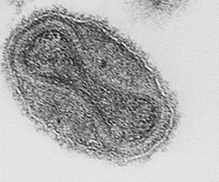
An image of smallpox virus.
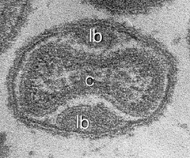
An image of cowpox virus
To test his idea, Dr. Jenner tried infecting people with cowpox on purpose, and then exposed them to smallpox. Amazingly, they didn’t catch smallpox. He didn’t know exactly how it worked, but we now know that cowpox and smallpox have antigens with similar shapes. This means that Memory Cells to fight cowpox can also fight smallpox. Because vacca means cow in Latin, Dr. Jenner called this type of disease prevention vaccination.
An illustration of a smoothie in a glass with a straw, and different fruits (strawberry, blueberries, banana).
After Dr. Jenner’s discovery, it became common to vaccinate everyone against smallpox. It has been so successful that since 1979 there have been no smallpox infections.
Today, we have many vaccines to protect us from getting sick. Most of these are shots, but some scientists are working on vaccines made in plants that you can eat. This might mean one day you won’t get a vaccine shot, you’ll just enjoy a vaccine smoothie!

